**Course Code: ANL252 Python for Data Analytics**

**End-of-Course Assessment**

**July 2022 Presentation**

**SUSS PI No: M2170763**

**Name: Reta D/O Rajakumar**

**Submission Date: 5 September 2022**

**Question 1**

Based on the data dictionary, the categorical columns are 'GENDER', 'EDUCATION','MARITAL','RATING'. The remaining columns consists of numerical variables.

**Code**

# using pd as an alias for pandas library

import pandas as pd

# using plt as an alias for matplotlib.pyplot

import matplotlib as mpl

import matplotlib.pyplot as plt

import seaborn as sns

# Import packages

import numpy as np

# read and show head of the dataset

df = pd.read_csv("ECA_data.csv")

df.head()

#print categorical variables

cat_cols=['GENDER', 'EDUCATION','MARITAL','RATING']

df1 = pd.DataFrame(df, columns=cat_cols)

df1

#print numerical variables

#select all columns except 'GENDER', 'EDUCATION','MARITAL','RATING'

df2 = df.loc[:, ~df.columns.isin(['GENDER', 'EDUCATION','MARITAL','RATING'])]

df2

**Image 1 to 3**

*Python code for Question 1*

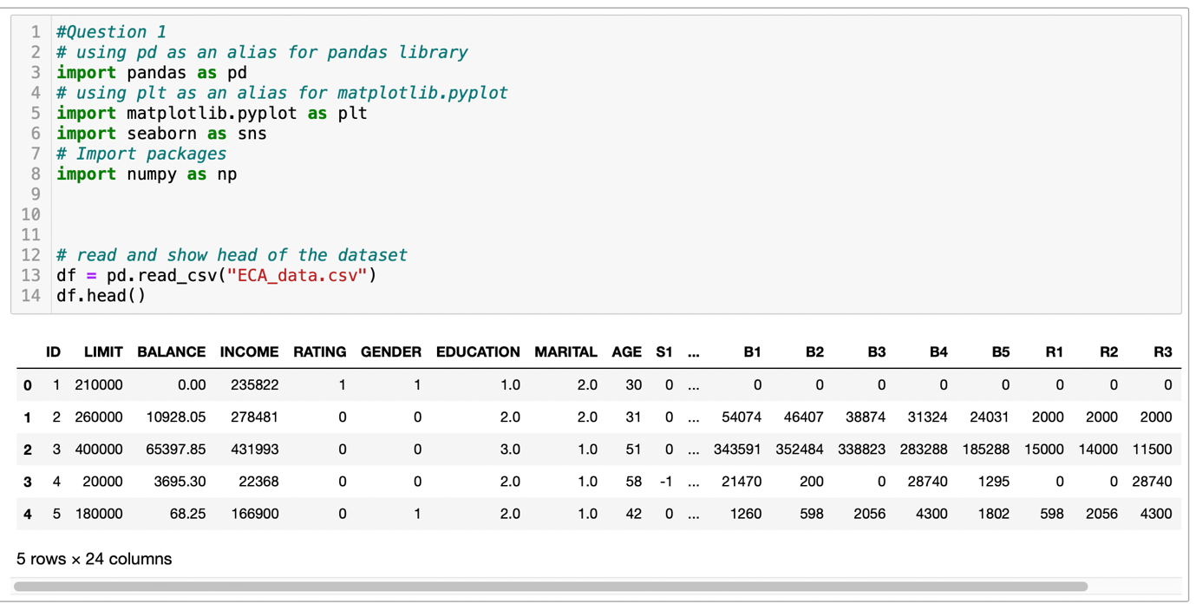

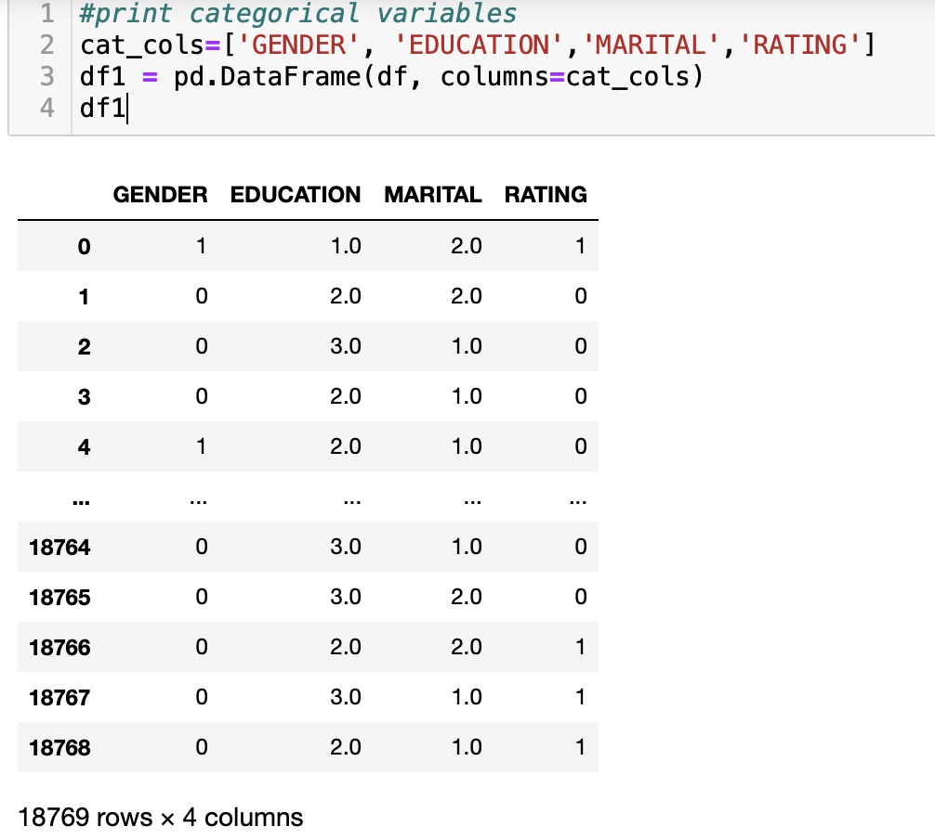

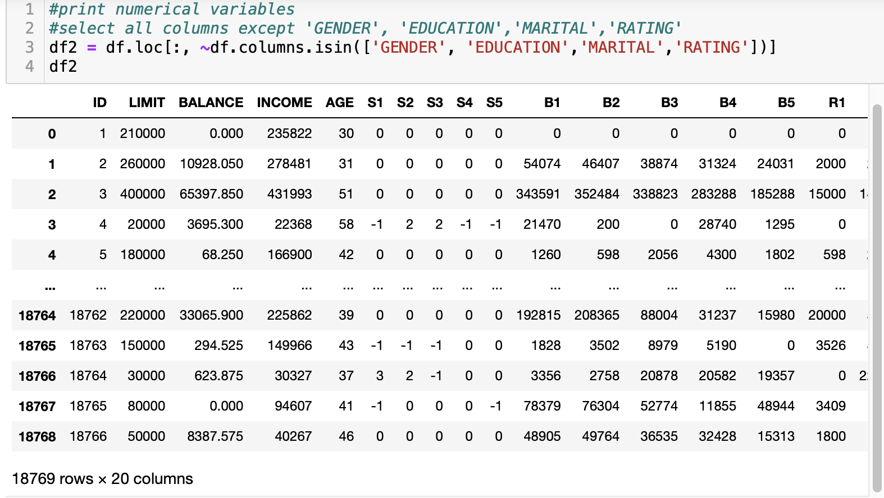

**Question 2**

**Data pre-processing task 1**

The first task is to identify duplicated rows. There were 3 rows found to be duplicated entries. The 3 rows duplicated rows are dropped as it would not be significant for data analysis.

**Code**

#Data pre-processing task 1

#Display all the rows of duplicated rows:

df_dup =df[df.duplicated(keep=False)]

df_dup

# Using DataFrame.drop_duplicates() to keep first duplicate row

df3 = df.drop_duplicates(keep='first')

df3

**Image 4 to 5**

*Python code for Question 2*

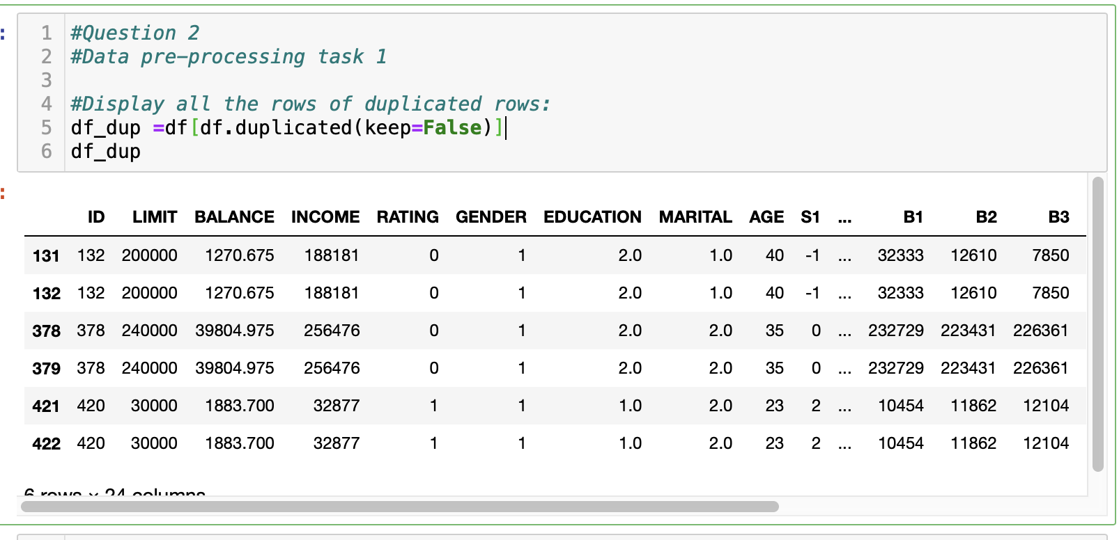

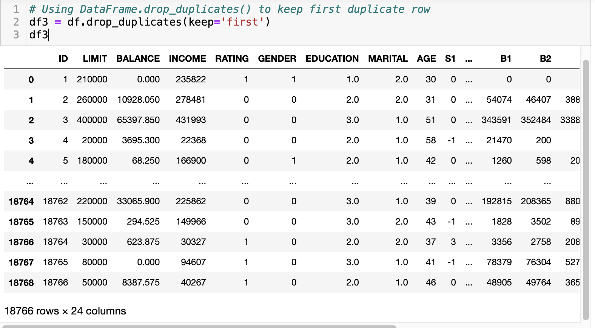

**Data pre-processing task 2**

Outlier age numbers had to be removed. Age was sorted by ascending, and then viewed by first and last 10 rows. It was shown that there were 5 rows with -1 and 5 rows with 199 for age. Rows with ages -1 and 199 were removed as 10 rows is not significant in a dataset with over 18 thousand entries.

**Code**

#Remove outliers values from age column

#Sort age by ascending

df4 = df.sort_values('AGE', ascending=True)

df4.head(10)

#show last 10 rows

df4.tail(10)

#show count of -1 in age column

df4['AGE'].value_counts()[-1]

#show count of 199 in age column

df4['AGE'].value_counts()[199]

#remove rows with -1 and 199 in age column

df5=df4[(df4.AGE != -1) & (df4.AGE != 199)]

df5

**Image 5 to 8**

*Python code for Question 2*

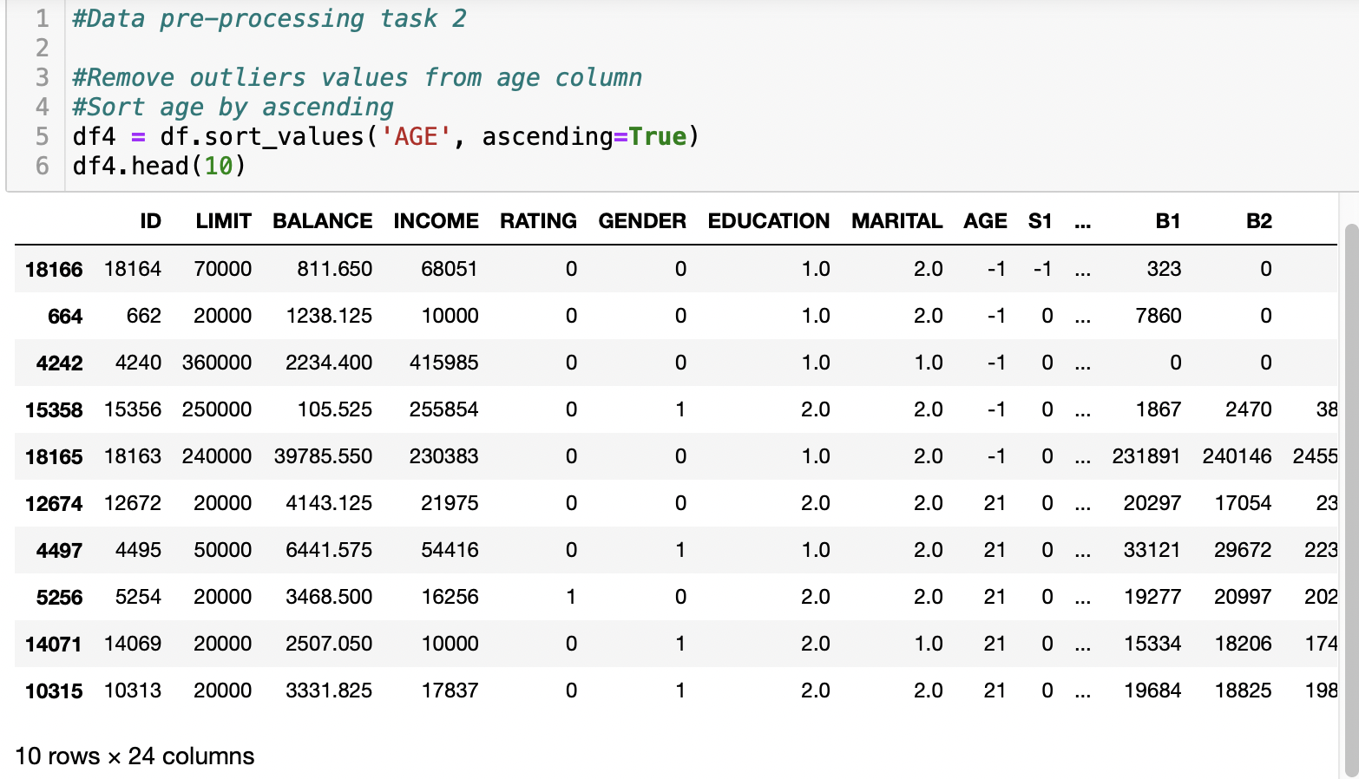

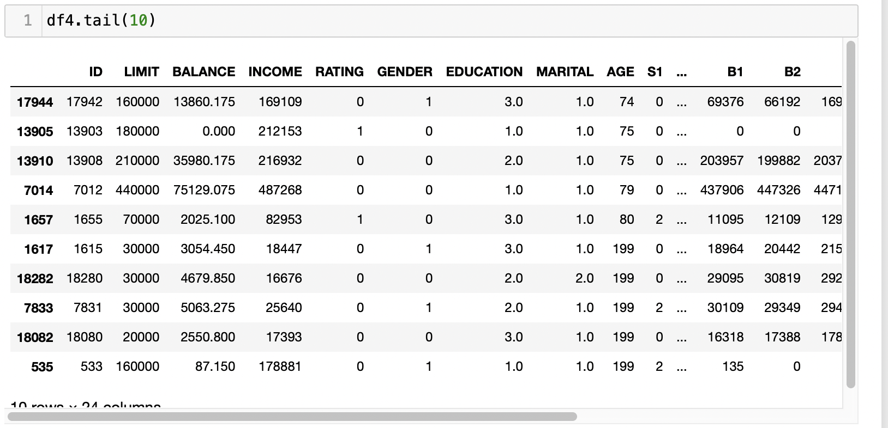

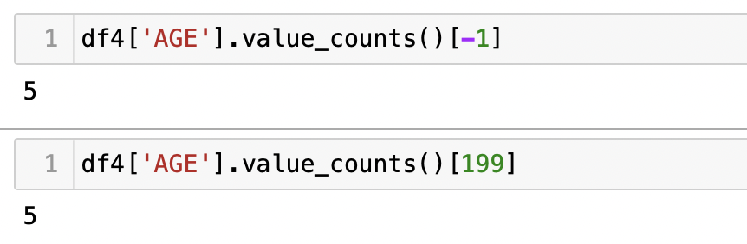

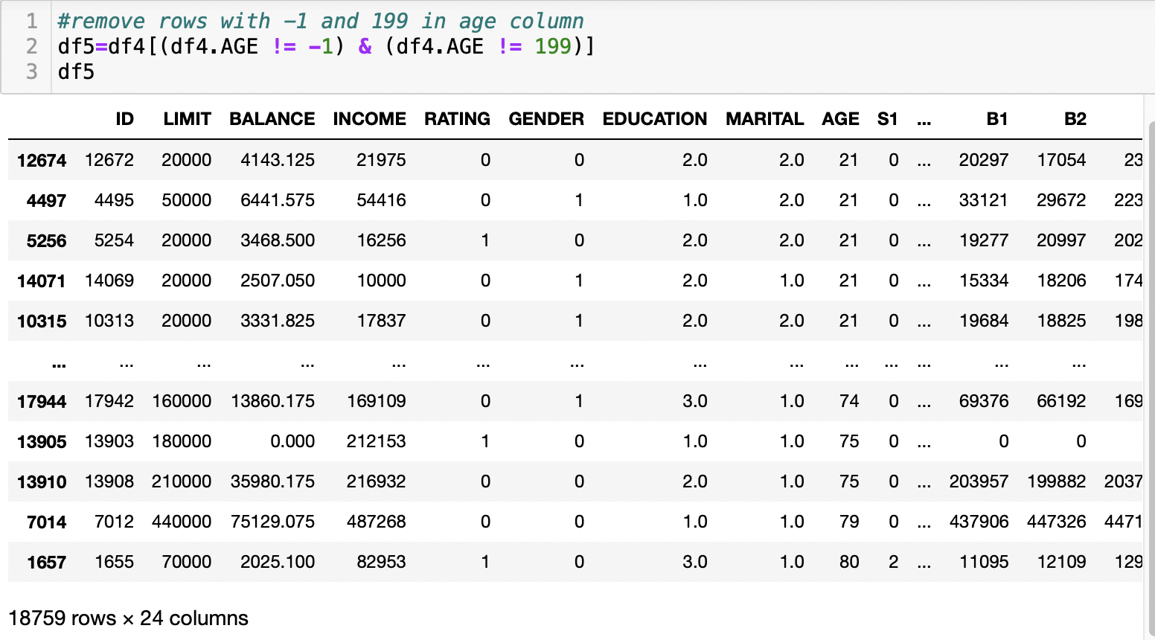

**Data pre-processing task 3**

Education and marital status are information that some customer may not wish to reveal, the values are missing at random . The mean, median and mode for Education is 2. Mean, median or mode could be used to replace missing values in EDUCATION column. Distribution plot was used to see if mean or median should be use to replace MARITAL missing values. Since there were outliers, the median of 2 was chosen.

**Code**

#Check sum and column of null missing values

print(df5.isnull().sum())

#check mean, median and mode values of EDUCATION and MARITAL columns

df5["EDUCATION"].mean()

df5["EDUCATION"].median()

df5["EDUCATION"].mode()

df5["MARITAL"].mean()

df5["MARITAL "].median()

df5["MARITAL "].mode()

#Distribution plot to see if mean or median should be use to replace MARITAL missing values

sns.distplot(df5.MARITAL)

df5['EDUCATION'] = df5['EDUCATION'].fillna(df5['EDUCATION'].median())

df5['MARITAL'] = df5['MARITAL'].fillna(df5['MARITAL'].median())

#Check sum and column of null missing values

print(df5.isnull().sum())

**Image 9 to 12**

*Python code for Question 2*

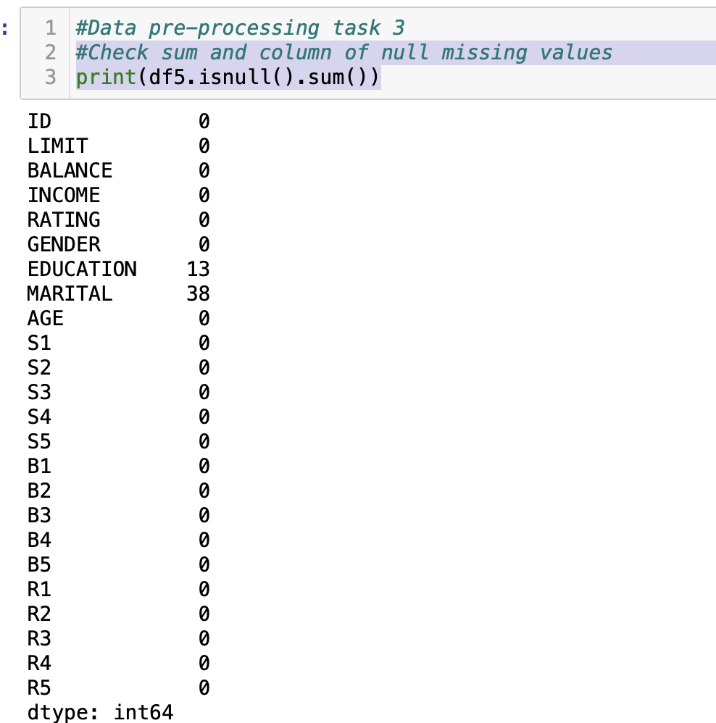

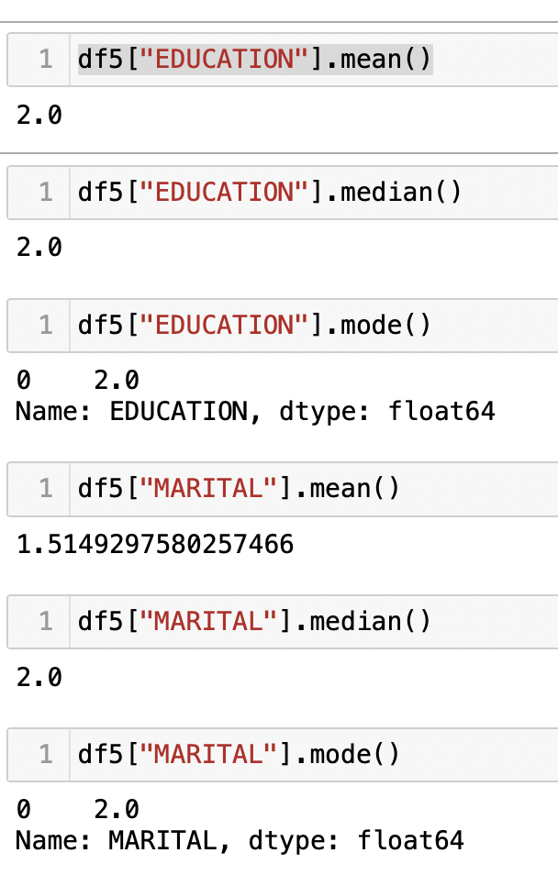

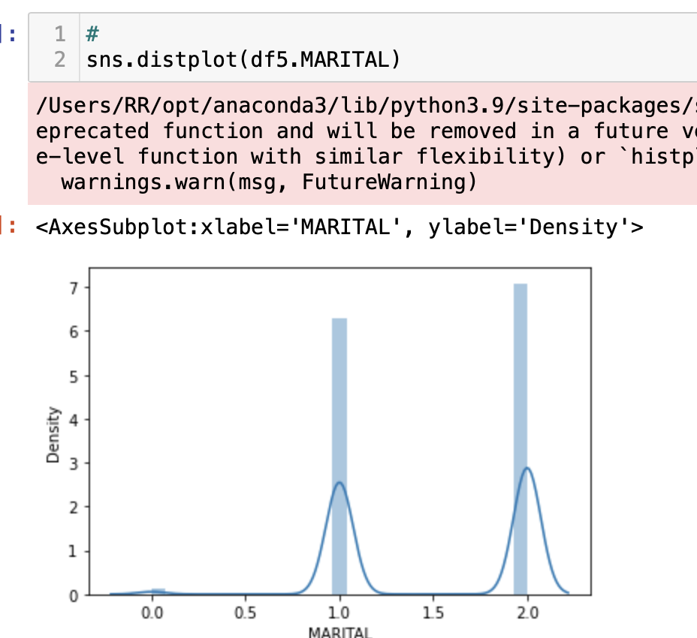

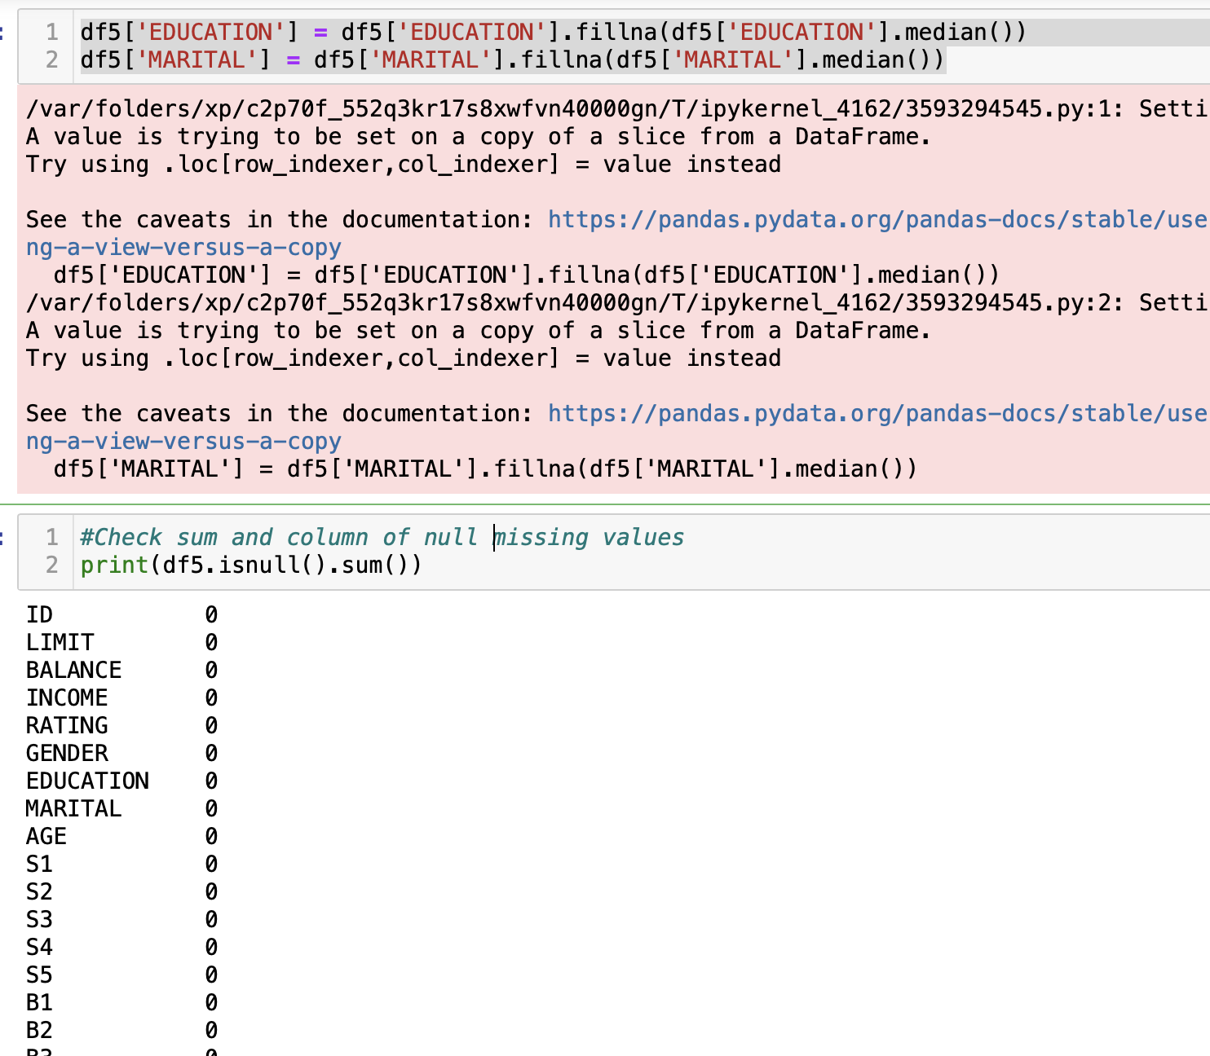

**Data pre-processing task 4**

Numerical variable column R3 data type was “object”. The column was not able to convert to “int” as there was a $ and comma sign in their values. This was shown in the ValueError message after using the code df5.astype(int). The code df5.astype(int) line was later removed so that the dollar and comma signs could be removed. This is so that the data type is uniform and usable.

**Code**

df5.info()

df5.astype(int)

#To remove all substrings "$" and ","

#To convert R3 column variables to numerical value

df5['R3'] = df5['R3'].replace("[$,]","", regex = True)

df5.astype({'R3': 'int'}).dtypes

**Image 13 to 14**

*Python code for Question 2*

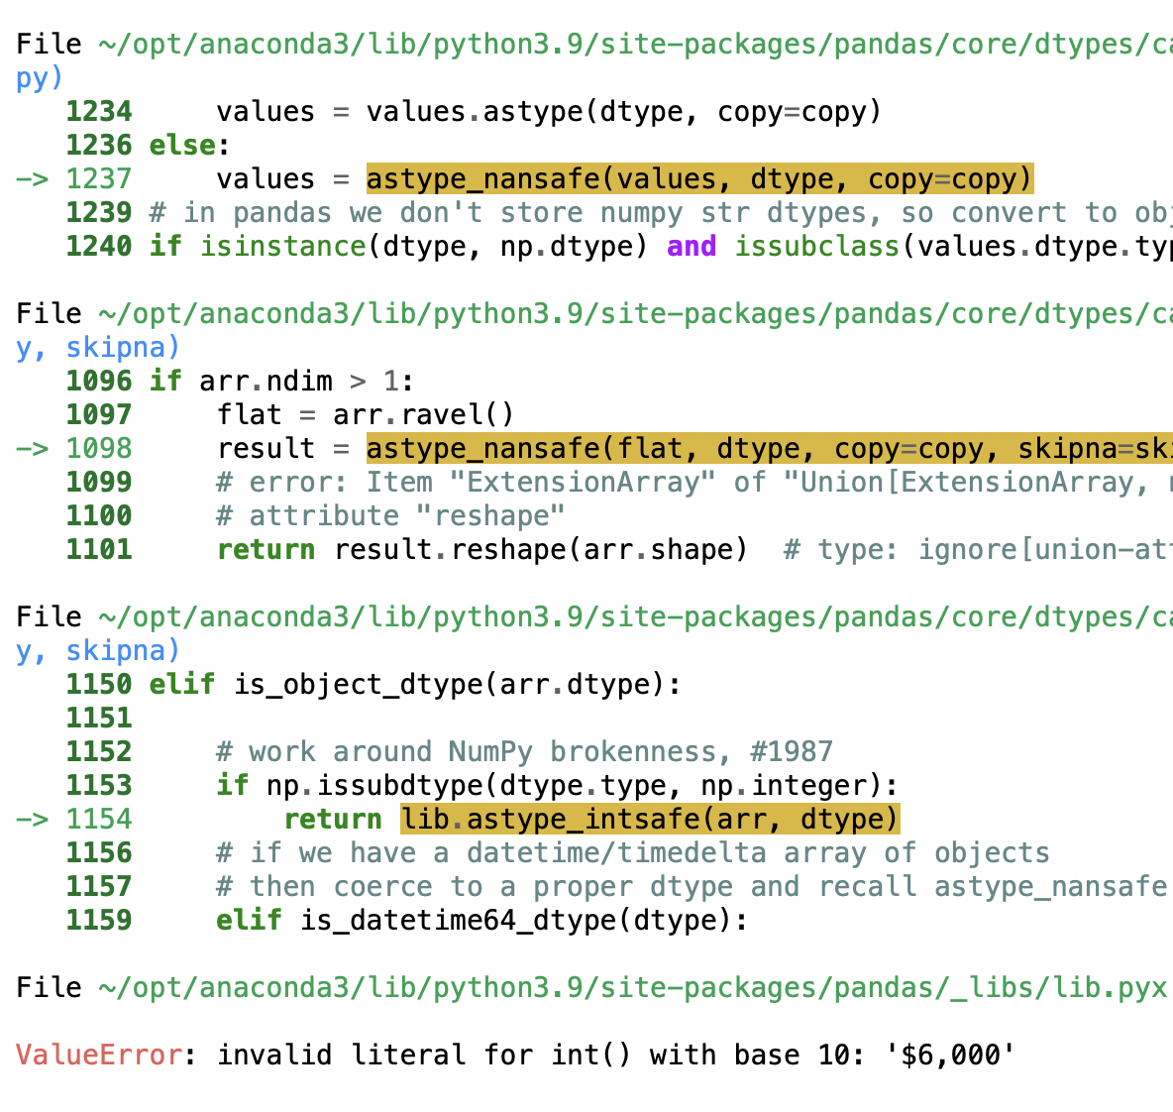

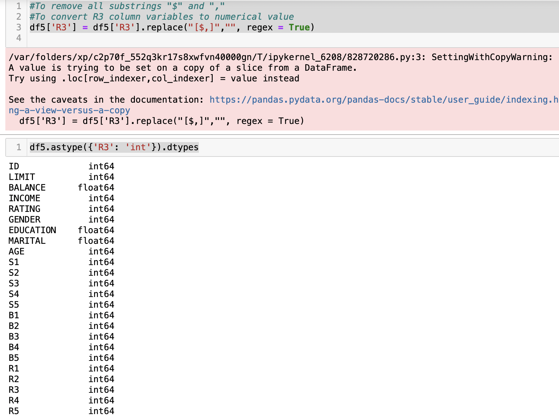

**Question 3**

**Correlation of Income and Total Loan Limit**

As seen in Diagram 1, income and total loan limit is highly correlated with a correlation value of 0.99. They have a strong positive correlation. This implies that the higher income a customer has, the higher loan limit they are given.

Customer’s payment behaviour is represented by S(n). Customers’ payment behaviour of current month has a moderate to strong relationship to the payment behaviour of the following month. The correlation is between 0.66 and 0.74. For instance, the correlation of S1 to S2 is 0.66.

**Code**

#Question 3

# data visualisation

# plotting correlation heatmap

corr = df5.corr()

plt.figure(figsize=(12,8))

sns.heatmap(corr, cmap="Greens",annot=True)

**Diagram 1**

*Heatmap Plot of Data Correlation*

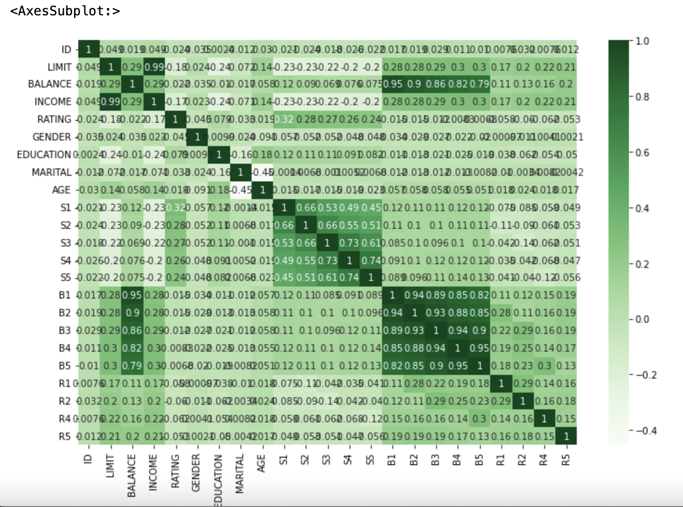

**Frequency of Customer Rating and Repayment Status**

Diagram 2 show the frequency of customer rating vs the customer repayment status in 1st to 4th months. Customers with good ratings tend to make prompt payment and minimum sum payment. There is a slight downward slope to show that those with good ratings avoids prolong delayed payments. Customers with bad ratings tend to delay their repayment for more months.

**Code**

# data visualisation 2: frequency

S1 =pd.crosstab(df5['S1'],df5['RATING'])

S1.div(S1.sum(1).astype(float), axis=0).plot(stacked=True,kind="bar")

plt.legend(['Good', 'Bad'])

S2 =pd.crosstab(df5['S2'],df5['RATING'])

S2.div(S2.sum(1).astype(float), axis=0).plot(stacked=True,kind="bar")

plt.legend(['Good', 'Bad'])

S3 =pd.crosstab(df5['S3'],df5['RATING'])

S3.div(S3.sum(1).astype(float), axis=0).plot(stacked=True,kind="bar")

plt.legend(['Good', 'Bad'])

S4 =pd.crosstab(df5['S4'],df5['RATING'])

S4.div(S4.sum(1).astype(float), axis=0).plot(stacked=True,kind="bar")

plt.legend(['Good', 'Bad'])

plt.show()

**Diagram 2**

*Histogram Plot of Frequency***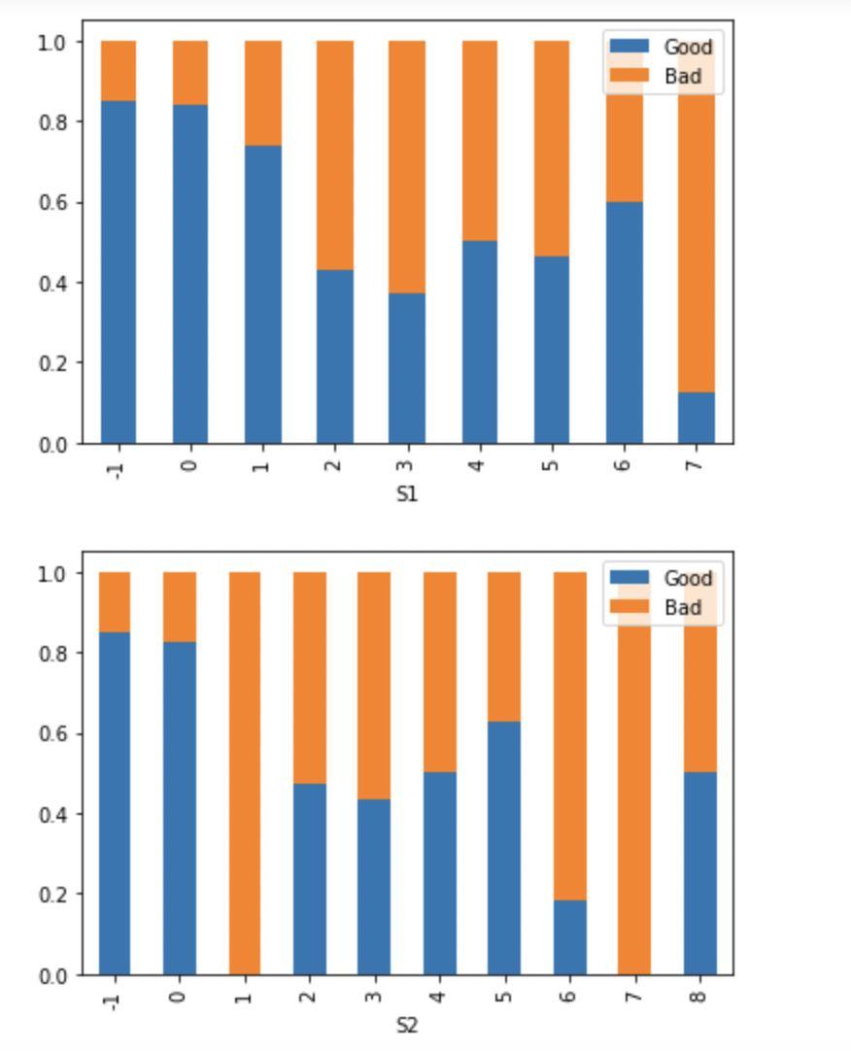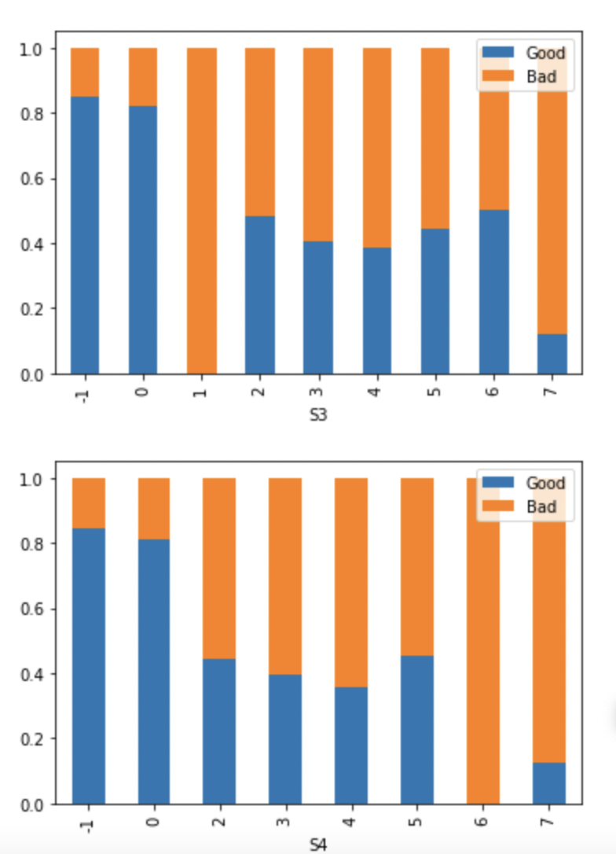**

**Credit Balance vs Billable Amount**

The scatterplots shows a strong, positive, linear association between credit balance and billable amounts. The higher credit balance the customer have, the higher the billable amounts for that month. There are also some outliers in the data. The data is scattered mostly on the bottom left, this shows that most people do not such high debt.

**Code**

# data visualisation 3: relationship

df.plot(x='B1', y='BALANCE', kind = 'scatter', color= 'red')

df.plot(x='B2', y='BALANCE', kind = 'scatter', color= 'red')

df.plot(x='B3', y='BALANCE', kind = 'scatter', color= 'red')

df.plot(x='B4', y='BALANCE', kind = 'scatter', color= 'red')

plt.show()

**Diagram 3**

*Scatter Plot of Relationship Between Credit Balance and Billable Amount*

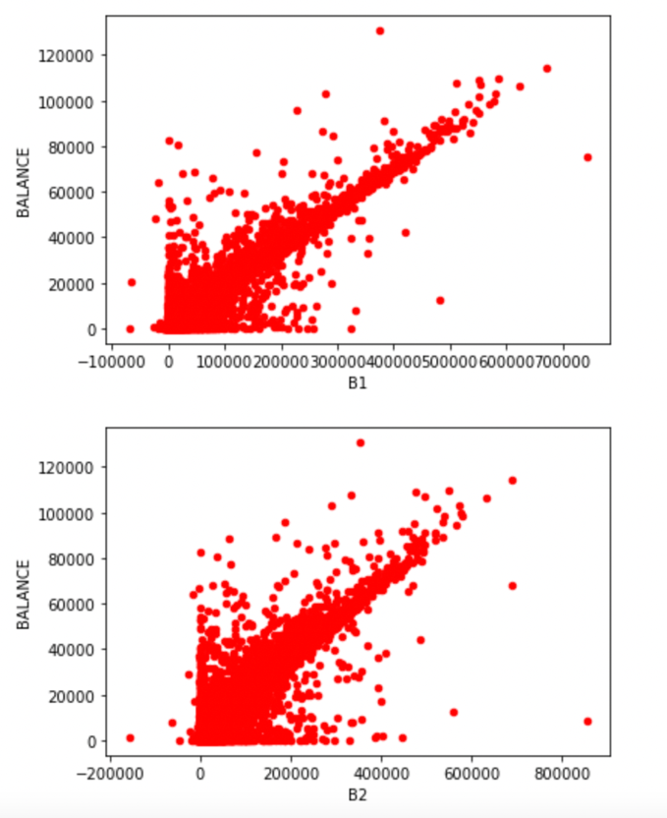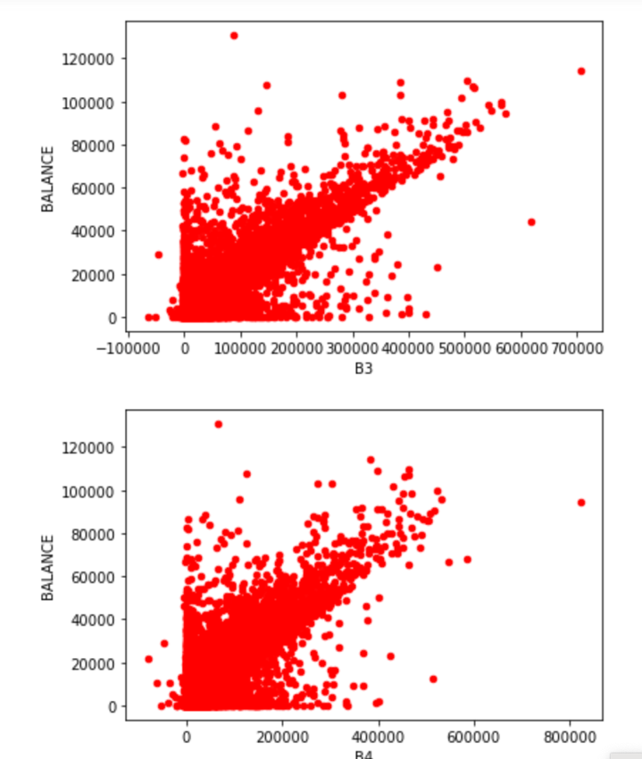

**Gender vs Education level**

The blue and orange bars represents male and female customers respectively. There are more female credit customers. The ratio of customers to education level remains almost unchanged with the 4 different education qualifications.

**Code**

*# data visualisation 4: Gender vs Education*

*Gender=pd.crosstab(df5['EDUCATION'],df5['GENDER'])*

*Gender.div(Gender.sum(1).astype(float), axis=0).plot(kind="bar")*

**Diagram 4**

*Histogram of Gender vs Education*

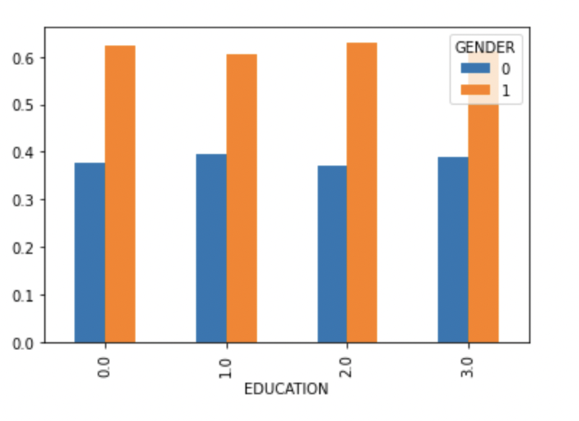

**Question 4**

As shown in Diagram 1 above, there is a high positive correlation between “B1” and “BALANCE” column of 0.95. Thus “BALANCE” is chosen to predict “B1” variables. “BALANCE” column contains the independent variables while “B1” column contains dependent variables whose values are to be predicted. To predict “B1” depending on the “BALANCE” variables, we store “B1” in X variable and “BALANCE” in Y variable. The date was then split 80% to the training set and 20% to the test set. ‘fit’ was used to train the test algorithim.

**Code**

from sklearn.model_selection import train_test_split

from sklearn.linear_model import LinearRegression

from sklearn import metrics

%matplotlib inline

y = df5['BALANCE'].values.reshape(-1, 1)

X = df5['B1'].values.reshape(-1, 1)

#split 80% of the data to the training set while 20% of the data to test set

X_train, X_test, y_train, y_test = train_test_split(X, y, test_size=0.2, random_state=0)

#train the algorithm

regressor = LinearRegression()

regressor.fit(X_train, y_train)

#To retrieve the intercept:

print(regressor.intercept_)

#For retrieving the slope:

print(regressor.coef_)

#make predictions on the test data

y_pred = regressor.predict(X_test)

#compare the actual output values for X_test with the predicted values

df = pd.DataFrame({'Actual': y_test.flatten(), 'Predicted': y_pred.flatten()})

df

# Check algorithm with scatterplot

plt.scatter(X_test, y_test, color='gray')

plt.plot(X_test, y_pred, color='red', linewidth=2)

plt.show()

**Image 15 to 16**

*Python code for Question 4*

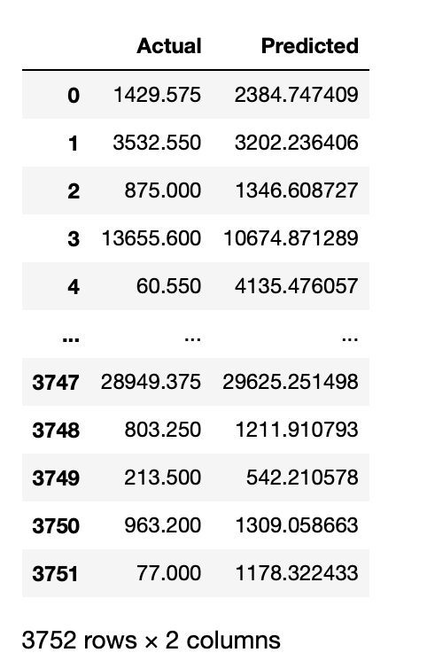

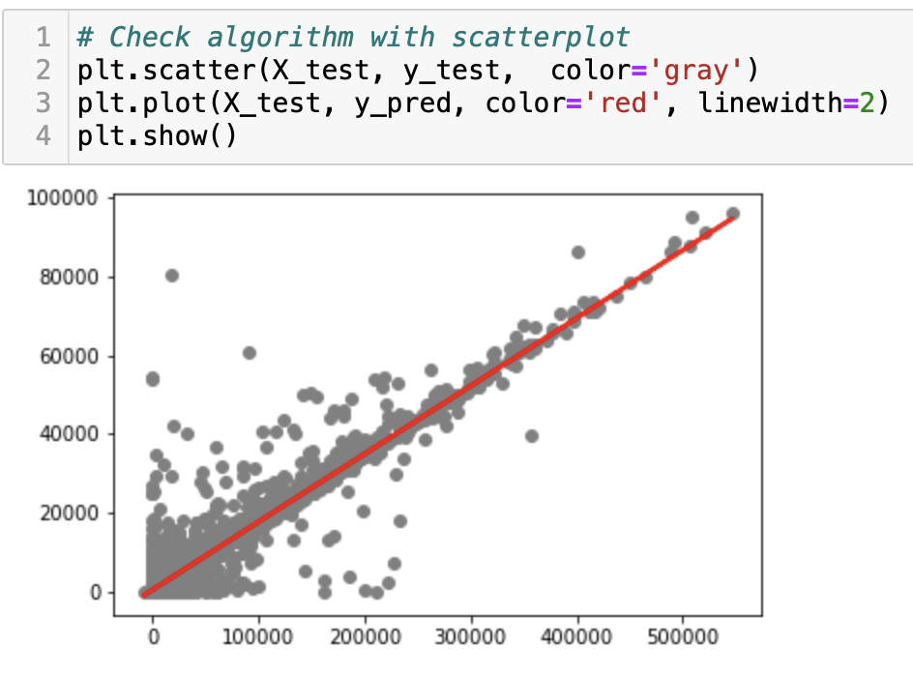

**Question 5**

The linear regression equation is Y = 0.17x + 485.37 (Y= mx + b). The intercept is 485.37 and slope is 0.17. This means that for every unit of change in the Credit Balance, there is a 0.17% change in B1 variable. We can now use the equation Y = 0.17x + 485.37 to manually predict variable of B1. However, this linear regression model is limited to a single variable and may not predict the B1 values efficiently. As seen in the scatterplot from Question 4, there are still plenty of noisy data in the algorithim.